Problem Solving Process
Your Name: _____________________________ Your Grade/Teacher: ____ /_______________ Today’s Date: ____________
My Side of the Story
Please use this form to tell your side of the story.

What was the Problem? | Draw a picture or write out what happened:
 | Write out or draw a picture of what happened: |  |  | When did this happen?  ______________________________  Where did this happen?  @ School / @ Home  My Issues / Friends Issue
Check in on how you feel about the problem…… | Circle how you feel About this situation?  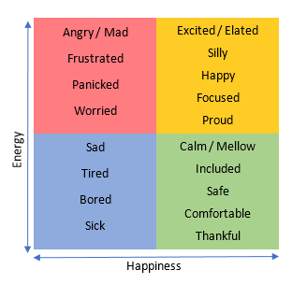 | Take a moment to Breathe and ReThink!    Any Ideas why you feel this way?
THINK of possible Solutions  &  EXPLORE the Outcomes | Share possible solutions a person could do? |  | What are possible outcomes from the solution?
 | (Ex: Tell the teacher / Talk to counselor) |  | (Ex: Teacher calls home – they get in trouble)
Pick a Solution | Share which solution you want to try:
Documentation (if needed) | Teacher Use only  Entered in TAC? ______  Parent Contacted? ____  Notes:

